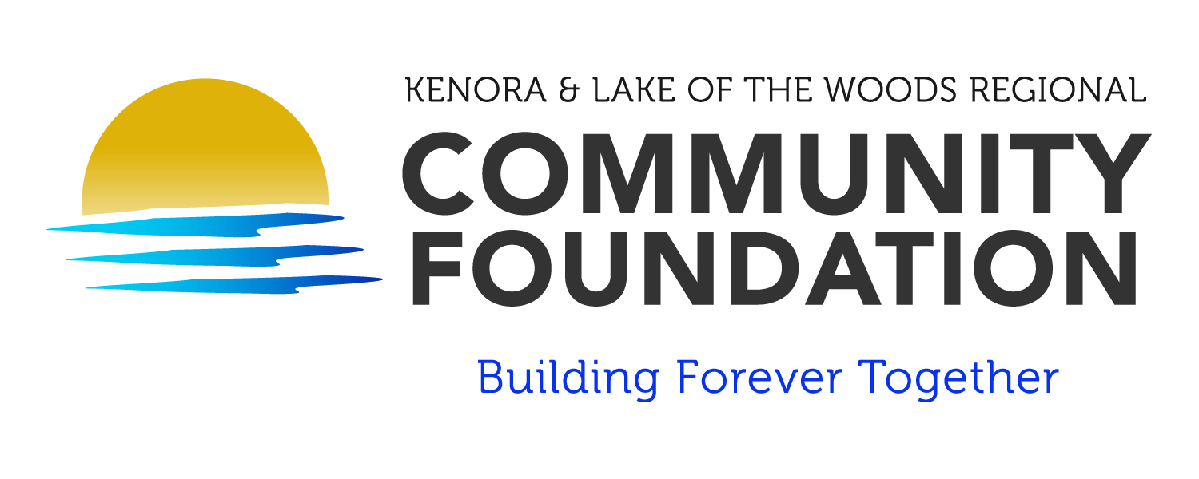

GRANT AGREEMENT

The Kenora and Lake of the Woods Regional Community Foundation is pleased to make a grant to your organization. The grant from the Foundation is for the explicit purpose(s) described below and is subject to your acceptance of the following conditions. To acknowledge your agreement to accept the grant, please return a signed copy of the agreement to the Foundation.

DATE OF APPROVAL:

GRANTEE:

CONTACT:

ADDRESS:

AMOUNT OF GRANT:

FINAL REPORT DUE DATE:

GRANT PURPOSE:

All grants are made in accordance with current and applicable laws and pursuant to the Income Tax Act, as amended, and the regulations issued therein. Please read the following carefully:

Reports to the Foundation
A final report on grant-supported projects is required as a condition of this grant. Your report should be submitted on or before the due date as specified above, with copies of appropriate receipts.

Announcing Grants
Grants approved by the Board of The Kenora and Lake of the Woods Regional Community Foundation are reported to the community through the Foundation’s annual report, media releases, website, other publications and events.

Grantee agencies are encouraged to make public announcements on their own, especially when such notices might stimulate additional support or help to spread word about important new projects. Prior approval should be obtained of wording used to describe the Foundation, its programs and the nature of the grant commitment.
Publications and promotional materials relating to this project produced by grantees should carry the following acknowledgement:
(GRANTEE) gratefully acknowledges the financial support of The Kenora and Lake of the Woods Regional Community Foundation, which is a public foundation serving the people of Kenora, Sioux Narrows/Nestor Falls, Minaki, Reddit, the First Nation Territories and the unincorporated areas surrounding Lake of the Woods. The Foundation builds permanently endowed charitable funds for the changing need and opportunities of the community and provides grants to eligible charitable organizations in the fields of; arts and culture, health and wellness, the environment, social welfare and the community fund”.

Please send one copy of each press release, and of published references to the grant, to the Foundation for its records.

Expenditures of Funds
This grant is to be used for the purpose described above and in accordance with the approved budget. The program is subject to modification only with the Foundation’s prior written approval.
- The grantee shall return to the Foundation any unexpended funds:
  - at the end of the grant period, or
  - if the foundation determines that the grantee has not performed in accordance with this agreement and approved program/budget, or
  - if the grantee loses its exemption from Federal income taxes under Section 110 of The Income Tax Act.

- No funds provided by the Foundation may be used for any political campaign, or to support attempts to influence legislation by any governmental body, other than through making available the results of non-partisan analysis, study and research.
- Expenses charged against this grant may not be incurred prior to the date of approval by the Board of Directors of The Kenora and Lake of the Woods Regional Community Foundation, and may be incurred only as necessary to carry out the purposes and activities of the approved program.
- The grantee organization is responsible for the expenditure of funds and for maintaining adequate supporting records consistent with generally accepted accounting practices.

Reports to the Foundation
A final report on grant-supported projects is required as a condition of this grant. Your report should be submitted on or before the due date as specified on the previous page, with copies of appropriate receipts.

Limit of commitment
Unless otherwise stipulated in writing, this grant is made with the understanding that the Foundation has no obligation to provide other or additional financial support to the grantee with reference to this grant.

THE KENORA AND LAKE OF THE WOODS REGIONAL COMMUNITY FOUNDATION email address: info@klwcf.ca

Per:

_____________________________________________ Date:_____________________________
(Authorized Signing Officer)

I HAVE AUTHORITY TO BIND KENORA AND LAKE OF THE WOODS REGIONAL COMMUNITY FOUNDATION

Acceptance by Grant Recipient

On behalf of the Grantee, I herby accept and agree to the terms of the grant as set forth in the above letter.

Date:______________________________________

Name of Organization:____________________________________________________________

_________________________________ ________________________
Signature Title

_________________________________ ________________________
Signature Title

WE/I HAVE AUTHORITY TO BIND THE GRANTEE

